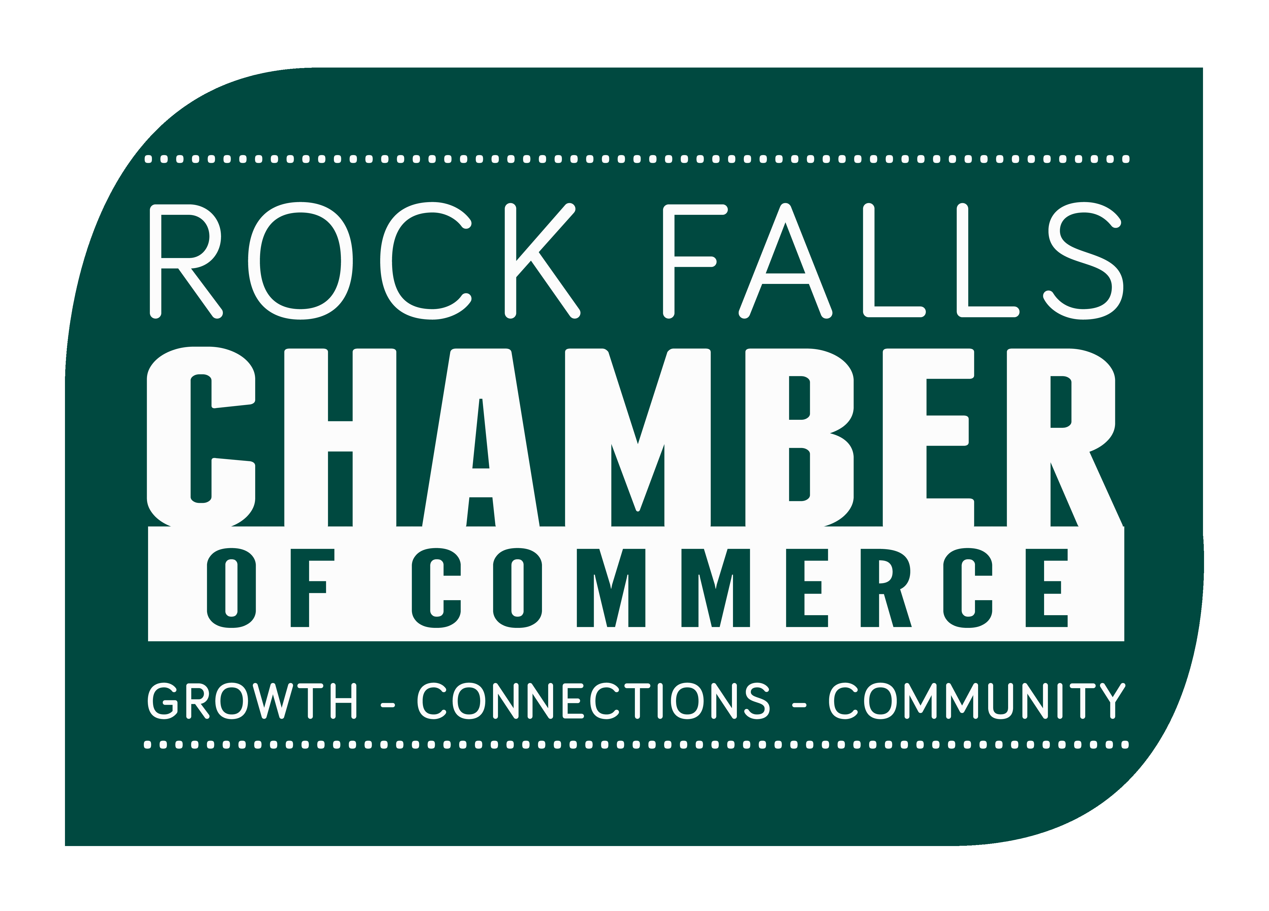 | Shoulder to the Wheel  Nomination Form  Recognition for outstanding volunteer service performed in Rock Falls.

The Shoulder to the Wheel Award honors the service of a Rock Falls volunteer. Their service to Rock Falls has been remarkable, a generous use of their personal time.

Nomination forms must be turned in no later than February 5th for review. The Shoulder to the Wheel Awards Committee will review nominations and select an award recipient to be presented at the Rock Falls Chamber of Commerce Annual Meeting and Dinner. Selections will be made without regard to race, creed, or sex.

Please select the correct category for your nominee
( ) INDIVIDUAL ( ) ORGANIZATION ( ) YOUTH ORGANIZATION
Name of nominee
Contact information for nominee
Through which business(es) or organization(s) has this person impacted the community?
Your name(s)
Your address, city, zip
Your phone number
and e-mail
Please fill out the section for the category you
have selected on the next page.

Return nomination forms to the Rock Falls Chamber, by 2/5/20. Mail or deliver to: 601 W. 10th Street, Rock Falls, IL 61071. Please call to arrange e-mail delivery 815-625-4500.
(Form Revised 1/2020)

INDIVIDUAL CATEGORY
Does the nominee’s work directly impact Rock Falls? ( ) YES ( ) NO
No recent past, or current chairperson of the Rock Falls Chamber board may be nominated.
- Is the nominee the chairperson or a recent past chairperson? ( ) YES ( ) NO
There is no limit on the number of times a person can be nominated, but a person may only win one time.
- Has this person been nominated before (to your best knowledge)? ( ) YES ( ) NO
- Has this person received this award, the Professional Service Award, or the Meritorious Service Award before?
( ) YES ( ) NO
Please answer the following questions on a separate piece of paper and submit with the nomination form.
- Describe the organizations and volunteer projects the nominee is involved with.
- Please describe how this person has served our community, specifically Rock Falls in a positive way.
(Examples of areas of service: Education, charitable work, business, government, Chamber of Commerce, senior citizens, youth, disabled, environmental, economic development, community relations, recreational programs, church groups, heroic acts, the arts, and general community service. Monetary donations are not applicable.)
- Please explain what specific activities were performed by this person & and who those activities helped.
(Examples of activities: Solved a community problem, development of a program and/or physical building, inspiring community movement, service to others.)
- When and where were the activities described performed?
- Please describe why this person stands out from others who serve in our community.

ORGANIZATION CATEGORY
Does the nominee’s work directly impact Rock Falls? ( ) YES ( ) NO
There is no limit on the number of times an organization can be nominated, but an organization may only win one time within three years.
- Has this organization been nominated before? (to your best knowledge) ( ) YES ( ) NO
- Has this organization received this award within the last three years? ( ) YES ( ) NO
Please answer the following questions on a separate piece of paper and submit with the nomination form.
- Please describe how this organization has served our community, specifically Rock Falls, in a positive way. List and describe specific programs and services provided, emphasizing special and recent work.
(Examples of areas of service: Education, charitable work, business, government, Chamber of Commerce, senior citizens, youth, disabled, environmental, economic development, community relations, recreational programs, church groups, heroic acts, the arts, and general community service.)
- What specific things stand out about this organization? Who are they helping?
(Examples of activities: Solved a community problem, development of a program and/or physical building, inspiring community movement, service to others.)
- When and where were the activities described done?
YOUTH ORGANIZATION CATEGORY
Does the nominee’s work directly impact Rock Falls? ( ) YES ( ) NO
There is no limit on the number of times an organization can be nominated, but an organization may only win one time within three years.
- Has this organization been nominated before? (to your best knowledge) ( ) YES ( ) NO
- Has this organization received this award within the last three years? ( ) YES ( ) NO
Please answer the following questions on a separate piece of paper and submit with the nomination form.
- Please describe how this youth organization has served our community, specifically Rock Falls in a positive way. List and describe specific programs and services provided, emphasizing special and recent work.
(Examples of areas of service: Education, charitable work, business, government, Chamber of Commerce, senior citizens, youth, disabled, environmental, economic development, community relations, recreational programs, church groups, heroic acts, the arts, and general community service.)
- What specific things stand out about this organization? Who are they helping?
(Examples of activities: Solved a community problem, development of a program and/or physical building, inspiring community movement, service to others.)
- When and where were the activities described done?

